**Student landing page after login**

Once the user has logged in is a student then he has the support from the system to either practice coding problems uploaded by teachers or to attempt test published by examiners only if the tests are enabled by the examiner.

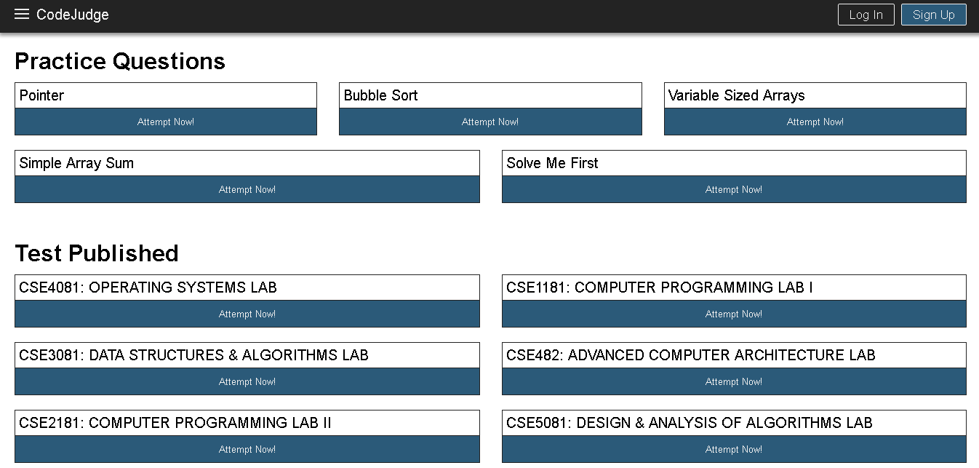Fig. 4.6: Student Home Page

**4.1.4 DIFFERENT OPERATIONS BY DIFFERENT USERS**

**Deleting Users**

Only the administrator has the access to view the registered users divided on the basis of their roles viz teachers, students and other admins as well. So as to prevent any misuse of the system the administrator has been provided with functionality to delete the existing users. The following screenshot depicts a confirmation message before deleting of the user from the system.

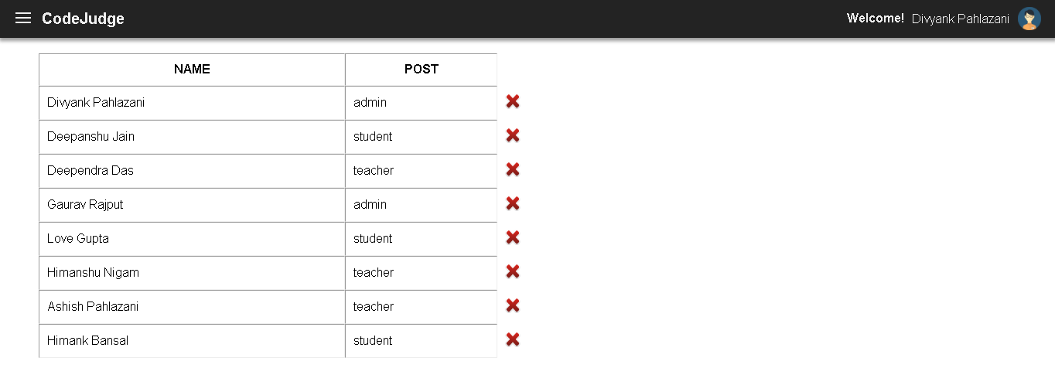Fig. 4.7: Database Modification by Administrator

**Publish Questions in a test**

Only the examiner has the power to publish test or publish practice questions on the portal along with the test cases defined by him for the same question.

The examiner can view the performance of the candidates on the basis of system’s evaluation keeping test cases as the prime parameter to be fulfilled by the code of the candidates.

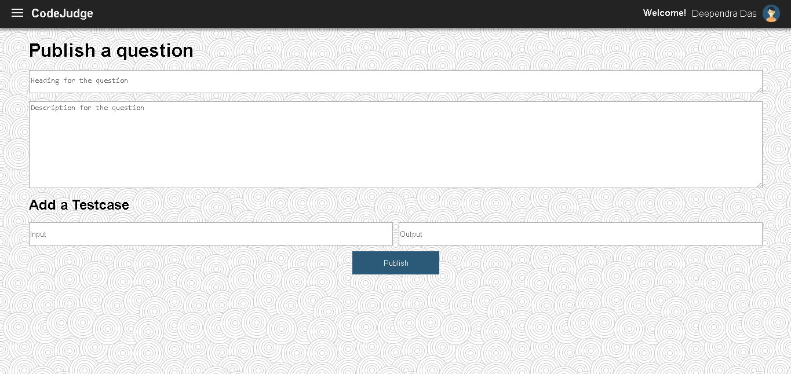Fig. 4.8: Publish Question

The published question can be either for practice of the students or it could be a part of the question set forming a test for a set of students.